Annmarie Mensah

Cohort A

09812026

Mobile Application Development

Dr Jamal-Deen

App Description

HealthTrack360 is a mobile application designed to help user to monitor and also improve their health through the tracking of their nutrition, exercise , sleep and their mood as well. Leveraging Firebase for secure authentication and cloud storage, and external APIs (Nutritionix, API Ninjas, Quotable) for enriched data, the app provides an easy and engaging user experience. With a visually appealing gradient design, intuitive navigation, and motivational content, HealthTrack360 encourages users to maintain healthy habits through real-time data visualization, offline support, and personalized feedback.

Key Features

* User Authentication: Secure login/signup with Firebase Auth

* Nutrition Tracking: Log food items with calorie estimation via API

* Exercise Monitoring: Track workouts, duration, and achievements

* Sleep Tracking: Monitor sleep hours and patterns

* Mood Tracking: Log emotional states with motivational content

* Data Analytics: Visualize health trends with charts

* Cloud Synchronization: Bidirectional sync with Firebase Firestore

* Local Storage: Offline data access with SQLite

* Backup & Restore: Complete data backup functionality

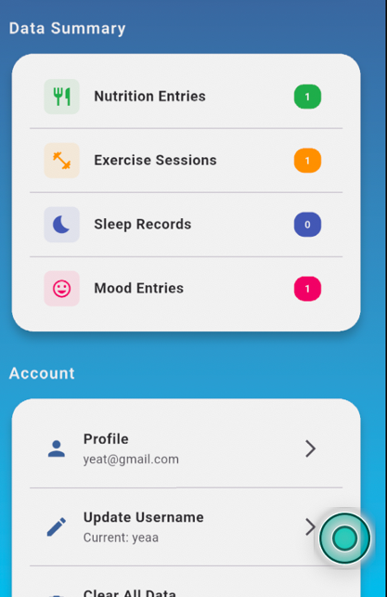

Widget Tree

.Home screen

Scaffold

└── Container (Gradient Background)

└── SafeArea

└── ListView

├── Row (Header)

│ ├── Container (Icon)

│ └── Text (Home)

├── HealthCard (Nutrition)

├── HealthCard (Exercise)

├── HealthCard (Sleep)

├── HealthCard (Mood)

└── HealthCard (Trends)

.Nutrition screen

Container (gradient background)

└── SafeArea

└── ListView

├── Row (header)

│ ├── Container (icon)

│ └── Text ("Nutrition")

├── _SectionHeader ("Today's Calories")

├── Card (calories display)

│ └── Column

│ ├── Text (calorie count)

│ └── LinearProgressIndicator

├── _SectionHeader ("Add Food")

├── Card (food input)

│ └── Column

│ ├── TextField (food name)

│ ├── TextField (calories)

│ └── ElevatedButton (add)

├── _SectionHeader ("Today's Meals")

├── ListView.builder (meals list)

└── Card (nutrition tip)

└── Text (tip content)

.Exercise Screen

Container (gradient background)

└── SafeArea

└── ListView

├── Row (header)

│ ├── Container (icon)

│ └── Text ("Exercise")

├── _SectionHeader ("Plan Your Workout")

├── Card (exercise form)

│ └── Column

│ ├── DropdownButtonFormField (exercise type)

│ ├── DropdownButtonFormField (specific exercise)

│ ├── Row (duration inputs)

│ │ ├── TextField (target duration)

│ │ └── TextField (actual duration)

│ ├── TextField (notes)

│ └── ElevatedButton (save)

├── _SectionHeader ("Today's Workouts")

├── ListView.builder (workouts list)

└── Card (achievement message)

└── Text (motivational content)

.

Sleep Screen

Container (gradient background)

└── SafeArea

└── ListView

├── Row (header)

│ ├── Container (icon)

│ └── Text ("Sleep")

├── _SectionHeader ("Log Your Sleep")

├── Card (sleep input)

│ └── Column

│ ├── Text ("Sleep Hours")

│ ├── Slider (sleep hours)

│ ├── Text (hours display)

│ └── ElevatedButton (save)

├── _SectionHeader ("Sleep History")

├── ListView.builder (sleep history)

└── Conditional Card (sleep tip)

└── Text (sleep advice)

.Moodscreen

Container (gradient background)

└── SafeArea

└── ListView

├── Row (header)

│ ├── Container (icon)

│ └── Text ("Mood")

├── _SectionHeader ("How are you feeling?")

├── Card (mood selection)

│ └── Column

│ ├── DropdownButtonFormField (emotion)

│ ├── TextField (notes)

│ └── ElevatedButton (save)

├── _SectionHeader ("Mood History")

├── ListView.builder (mood history)

└── Conditional Card (motivational content)

└── Text (motivational message)

.Loginscreen

Scaffold

├── AppBar

│ └── Text (Login)

└── Column

├── CustomTextField (Email)

├── CustomTextField (Password)

├── ElevatedButton (Login)

└── TextButton (Register)

.Splashlogin screen

└── Container (Gradient Background)

└── SafeArea

└── Column

├── Expanded (Logo & Title)

│ ├── Container (Circle with Icon)

│ └── Text (HealthTrack360)

├── TabBar (Login/Signup)

└── Expanded (TabBarView)

├── _LoginForm

│ ├── CustomTextField (Email)

│ ├── CustomTextField (Password)

│ ├── ElevatedButton (Login)

│ └── TextButton (Forgot Password)

└── _SignUpForm

├── CustomTextField (Username)

├── CustomTextField (Email)

├── CustomTextField (Password)

└── ElevatedButton (Sign Up)

. RegisterScreen

Scaffold

├── AppBar

│ └── Text (Register)

└── Column

├── CustomTextField (Username)

├── CustomTextField (Email)

├── CustomTextField (Password)

└── ElevatedButton (Register)

Settings screen

Scaffold

├── AppBar

│ ├── IconButton (back)

│ └── Text ("Settings")

└── Body

└── Container (gradient background)

└── SafeArea

└── ListView

├── Row (header)

│ ├── Container (icon)

│ └── Text ("Settings")

├── _SectionHeader ("Data Management")

├── Card (sync options)

│ └── Column

│ ├── ListTile (Sync with Cloud)

│ ├── ListTile (Create Backup)

│ └── ListTile (Clear All Data)

├── _SectionHeader ("Account")

├── Card (account options)

│ └── Column

│ ├── ListTile (Profile)

│ └── ListTile (Delete Account)

├── _SectionHeader ("App")

├── Card (app options)

│ └── Column

│ ├── ListTile (About)

│ └── ListTile (Logout)

└── SizedBox (bottom padding)

Main Navigation

Scaffold

├── Drawer (_ProfileDrawer)

├── AppBar

│ ├── IconButton (menu)

│ ├── Text (dynamic title)

│ └── IconButton (refresh)

└── Body

└── IndexedStack

├── HomeScreen

├── NutritionScreen

├── ExerciseScreen

├── SleepScreen

├── MoodScreen

└── SettingsScreen

└── BottomNavigationBar

└── 6 BottomNavigationBarItems

Lesson learned

State Management: Provider pattern provides excellent separation of concerns

Data Persistence: Hybrid approach (local + cloud) ensures reliability

Github link: <https://github.com/annmarieakuba/health360>